# Overview

Upon completion of this chapter, the participant will be able to:

* Discuss the benefits of using preferences to optimize the use of Project Server by configuring PWA and Project Pro options.
* Describe the purpose of the cache and queue.
* List the steps to clear the local cache.
* Monitor the queue and review jobs in progress.
* Configure personal and resource alerts and reminders.

# Optimizing Through Preferences

Project managers will reduce frustration by becoming familiar with how Project Server processes information and how that affects the visibility and speed of changes. Project managers will save time by optimizing the project environment to suit personal preferences. In Managing Project Manager Preferences we will provide insight into how project managers can gain control within Project Pro and PWA by displaying and setting various options.

# Managing the Cache

A feature that helps ensure high performance and data reliability is the cache. The cache is available locally in Project Professional (aka, Project Pro) and is a temporary storage location for data until Project Server has completed the synchronization between Project Pro and Project Web App (PWA).

## Overview of Caching

Caching occurs by storing information on a local machine first before exchanging information with the server. Since Project Pro is operating in a connected mode, caching provides a way to quickly open recently retrieved schedules and a way to save changes to schedules locally and synchronize that information with PWA at a later time.

Using a local cache allows a project manager to save schedules and avoid lengthy time delays. It also ensures that even if there is a failure to connect or an interruption in the connection with PWA the information will not be lost since it is still maintained in the local cache. When the connection is reestablished, the local cache can be synchronized.

Synchronization with PWA ensures that the changed information from the local cache is available when retrieving files from the server, only the changed information is passed to the local cache. Synchronization of changes also saves server processing time, ensures reliability of data, and reduces wait times for the end user.

## Clearing the Local Cache

Information about the local cache can be displayed, monitored and modified. Within the local cache, you can control which projects are taking up hard drive space in Project Pro. In order to improve performance of Project Pro or if you would like to remove projects that you no longer need from the cache, you can clear the local cache.

To clear the local cache:

1. Open Project Pro.

You should keep all of your projects closed so they are not modifying the cache that you are planning to clear.

1. From the File tab, click Options.
2. In the Project Options dialog box, select Save.
3. In the Cache section, click Clean Up Cache.

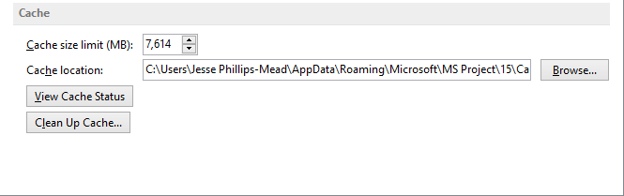

1. Cache Options on the Save Tab of Project Option [Cache Options on the Save Tab.tif]

If the Clean Up Cache button is unavailable, you are running Project in desktop mode (computer profile). You need to restart Project and select the profile that connects Project Pro to PWA.

1. In the Clean Up Cache dialog box, in the File Name column select the desired project(s) and click Remove From Cache.
2. Click Close.
3. Click OK.

## Factors Affecting Performance

There are several areas to consider that may affect application performance. Optimizing performance by working with the cache improves processing speed in projects that will require frequent saving or changing.

Below are some tips to ensure you are following best practices when it comes to cache settings or cache management.

* Auto saving single or multiple projects at once utilizes cache space. You may want to consider turning auto save off.
* Too small of a limit on cache size may decrease performance when working with multiple projects. You may want to increase the size of the cache.
* Old information in the cache may occupy valuable space. You may want to schedule a regular cleanup of the cache to remove unused projects.

Caching is a useful feature when there is one person functioning as the project manager and that is the only person who will be opening the schedule in Project Pro. If other people are editing the schedule in Project Pro, your local cache will be out of sync with the most recent copy and it will take time to update it next time you open it.

# Managing the Queue

Project Server uses the queue service to line up work requests that are waiting until the server becomes available to act on the request. This functionality works very much the way a print queue works and improves the performance of Project Server. The Project Queuing System provides reliability, scalability and manageability by better utilizing server resources.

The Project Server Queuing System can hang on occasion for many reasons. This requires some administration know-how in order to resolve these stuck jobs and is beyond the scope of this book.

## Overview of Queue Service

A queue is a waiting line that becomes a necessity when the number of service requests becomes greater than the optimum serving capacity. The following are examples of when a queue may be needed:

* In an organization, at the end of the workday on Friday, nearly all 300 employees submit their timesheets.
* A few hours before their team status meeting, nearly all project managers publish their projects.

The purpose of the Project Server Queuing System is to handle these kinds of changes consistently. The Queuing System takes all the users’ input, records entries for the requests in Microsoft SQL Server, and then processes the data asynchronously on a first-come, first-served basis. The Queuing System ensures that Project Server works reliably when there is a sudden upsurge in demand. The following jobs in PWA go through the Project Server Queuing System:

* Project Save
* Project Publish
* Timesheet Save
* Timesheet Submit
* Project Backup/Recovery
* Report Data Service operations
* Cube Building Service operations
* Server Side Scheduling (and node-consistency processing)

If a project manager expects that there may be issues in the Project Server Queuing System, they should consult with their administrator to troubleshoot queue settings.

How to view the Queue:

1. In the Quick Launch menu, click Server Settings.
2. In Personal Settings, click My Queued Jobs.

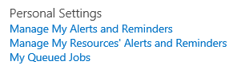

1. Personal Settings List of Options [Personal Settings List of Options.tif]
2. Any jobs in process will be listed.

# Managing Alerts and Reminders

You can set alerts and reminders for upcoming and overdue tasks and status reports in PWA. These alerts and reminders are email-based notifications that are established on the settings defined in PWA.

The ability to receive e-mail notifications from PWA is controlled by your administrator. You should consult your administrator if alerts and reminders are not being received.

There are two types of notifications:

Alerts – you can set alerts to receive email notification immediately when some action has occurred with your task or status report. Task alerts are sent immediately. For example, you can turn on alerts that will notify you when you receive a new task assignment, or when you receive a new status report request.

Reminders – you can configure reminders to receive email notification when attention is needed on tasks and status reports. Reminders are based on conditions, and are sent according to a recurrence schedule that you define, such as every three days. Task reminders are sent daily via e-mail at a time set by the administrator. For example, you can set up a reminder that will notify you a day before a status report is due.

## Managing Personal Alerts and Reminders

A personal alert or reminder is a section of PWA that is controlled by the individual. Personal alerts and reminders can be set for task and status reports by using the Personal Settings page on PWA.

To configure personal alerts and reminders:

1. In the Quick Launch menu, click Server Settings.
2. In Personal Settings, click Manage My Alerts and Reminders.

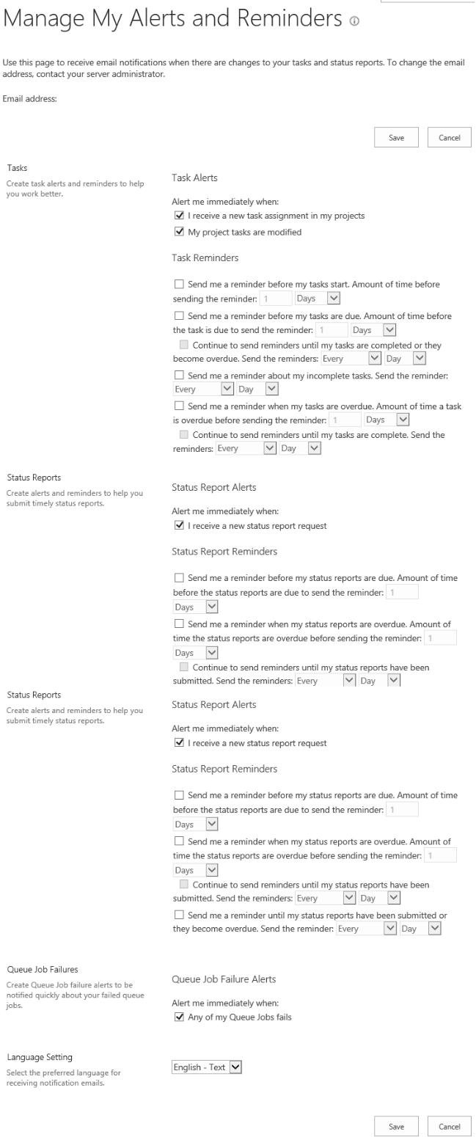

1. My Alerts and Reminders [My Alerts and Reminders.tif]
2. To set alerts for Tasks, configure the foll owing:

* If you want to receive email notifications immediately upon the occurrence of specified events, in the Task Alerts, Alert me immediately when: section, select the appropriate checkboxes to set email alerts to be sent when you receive new task assignments and when your tasks are modified
* If you want to receive email notifications at specified intervals, in the Task Reminders section, select the appropriate checkboxes to set email alerts to be sent before tasks start, before tasks are due, for incomplete tasks, and for overdue tasks. For each interval, specify the frequency.

1. To set alerts for Status Reports, configure the following:

* If you want to receive email notifications immediately upon the occurrence of specified events, in the Status Reports Alerts, Alert me immediately when: section, select the I receive a new status report request checkbox to set email alerts to be sent when you receive a new status report request.
* If you want to receive email notifications at specified intervals, in the Status Reports Reminders section, select the appropriate checkboxes to set email alerts to be sent when status reports are due, when your status reports are overdue, and when status reports are submitted or have become overdue. For each interval, specify the frequency.

1. In the Queue Job Failure Alerts section, select to be alerted of failed jobs (refer to the section Managing the Queue for a detailed explanation of this topic).
2. In the Language Setting section, select the language and format that you want to use for your notifications.
3. Click Save.

## Managing Alerts and Reminders for Resources

Project managers can set up alerts and reminders for their resources. In this case, team members will receive both the project manager defined notifications and the notifications that they defined for themselves.

The section My Team Member Tasks is a feature that applies only to resources on projects you are the project manager or owner of. The section My Resources’ Status Reports is a feature that only applies to resources you have created a new status report request for.

To configure alerts and reminders for resources:

1. In the Quick Launch menu, click Server Settings.
2. In Personal Settings, click Manage My Resources’ Alerts and Reminders.

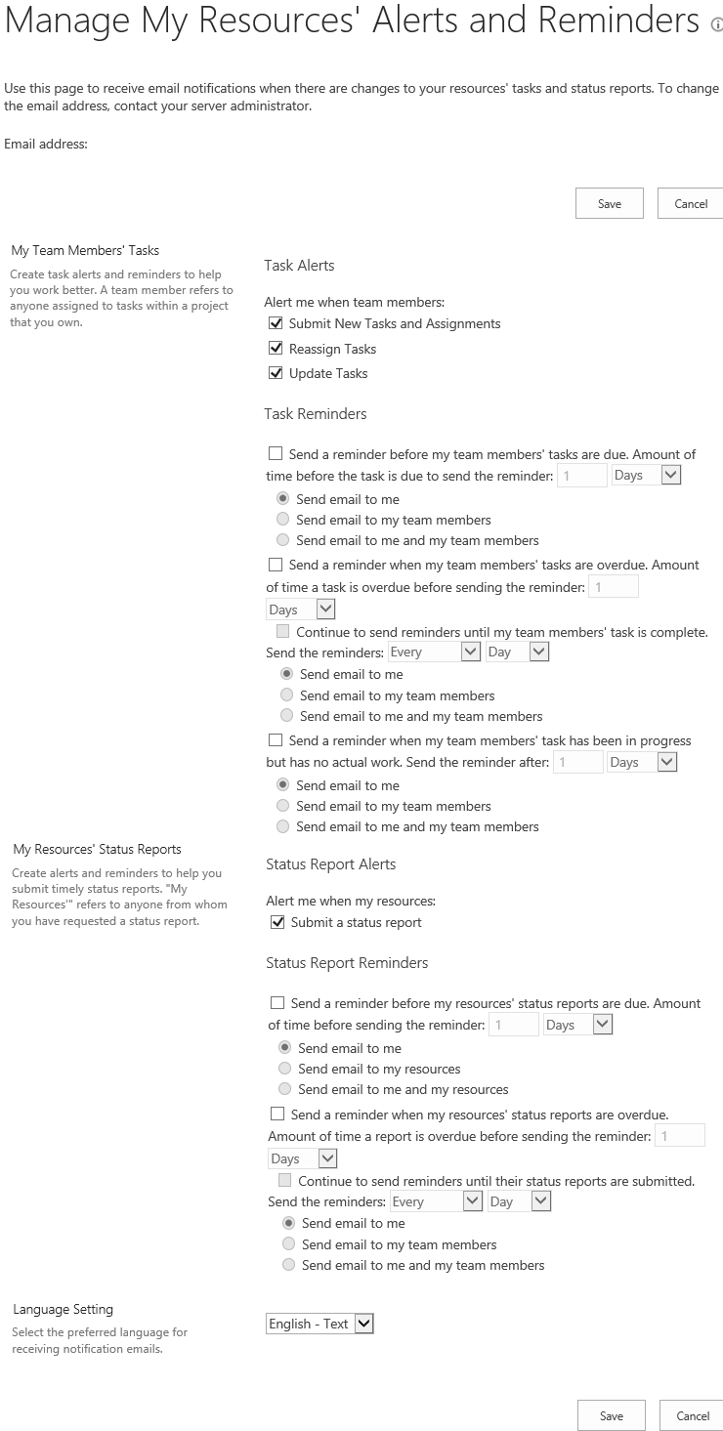

1. My Resources’ Alerts and Reminders [My Resources Alerts and Reminders.tif]
2. To establish alerts for tasks as signed to your resources configure the following:

* If you want to receive email notifications immediately upon the occurrence of specified events, in the Task Alerts, Alert me when team members: section, select the appropriate checkboxes to set email alerts to be sent when your resources submit new tasks and assignments, when your resources reassign tasks, and when your resources update tasks.
* If you want to receive email notifications at specified intervals for upcoming tasks, in the Task Reminders section, Send a reminder before my team members’ tasks are due section, select the appropriate option to set email alerts to be sent before tasks are due and have the alerts sent to only you, only to your resources, or both to you and your resources. You can also specify the number of days in advance of the due date for the upcoming task that the email notification is sent.
* If you want to receive email alerts at specified intervals for overdue tasks, in the Send a reminder when my team members’ tasks areoverdue section, select the appropriate checkboxes to set email alerts. Select the appropriate option to set the alerts to be sent to only you, only to your resources, or both to you and your resources. You can also specify the number of days past the due date for the overdue task at which the alert is sent and the frequency at which reminder emails are sent until the task is complete.
* If you want to receive email notifications at specified intervals for tasks that require updates, in the Send a reminder when team members’ task has been in progress but has no actual work section, select the appropriate options to set email alerts to be sent when a task is started, but has not reported actual work, and have the alerts sent only to you, only to your resources, or both to you and your resources. You can also specify the number of days after the task has started that an alert is sent.

1. To establish alerts for your resource’s status reports configure the following:

* If you want to receive email notifications immediately when your resources send a status report, in the Status Report Alerts, Alert me when my resources: section, select the checkbox to set email alerts to be sent when your resources submit a status report.
* If you want to receive email notifications at specified intervals for upcoming status reports, in the Status Report Reminders, Send a reminder when my resources’ status reports are due section, select the appropriate option set email alerts to be sent when a resource’s status report is due and have the alerts sent only to you, only to your resources, or both to you and your resources. You can also specify the number of days in advance of the due date for the status report at which the alert is sent.
* If you want to receive email notifications at specified intervals for overdue status reports, in the Status Report Reminders, Send a reminder when my resources’ status reports are overdue section, select the appropriate options to set email alerts to be sent when a resource’s status report is overdue and have the alerts sent only to you, only to your resources, or both to you and your resources. You can also specify the number of days past the due date for the status report at which the alert is sent and the frequency at which reminder emails are sent until the status report is submitted.

1. In the Language Setting section, select the language and format that you want to use for your notifications.
2. Click Save.

# Key Points to Remember

* Capturing your Project Server environment preferences will streamline work and efficiencies will be gained.
* Caching enables quicker processing in synchronizations between Project Pro and PWA.
* If performance is lagging, a project manager can clear the local cache to free up processing space.
* Project managers should understand how the Project Server Queuing System works to be able to identify when there will be delays in refreshing of information.
* A project manager can set alerts and reminders for themselves and their team members for upcoming and overdue work. Team members can also set their own personal alerts and reminders for their tasks.